**Just one more thing…** we use ‘**Tapestry**’, an online journal, to record the children’s activities in the Early Years classes – remember to check often to see what activities your child engages in while at school. It is also a great way to interact with staff members and add your own photos and comments. If you have any questions please don’t hesitate to ask!

**Fab Fridays (and other days!)**

A reminder that our Friday morning sessions are often spent outside and the children are encouraged to wear suitable clothing (warm/waterproof coats, no ‘best’ clothes, they will get muddy!) If you prefer, your child can leave their named wellies on their peg.

**PE sessions** are on **Tuesdays** – the children can wear trainers, joggers/leggings and their school t-shirts and jumpers on these days as we are not changing for PE at the moment.

All school jumpers, coats and bags should be **clearly named** to ensure no mix ups occur!

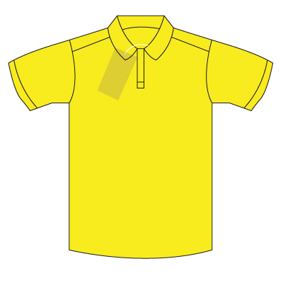 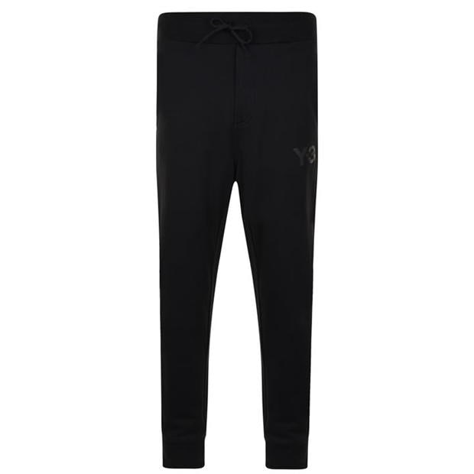 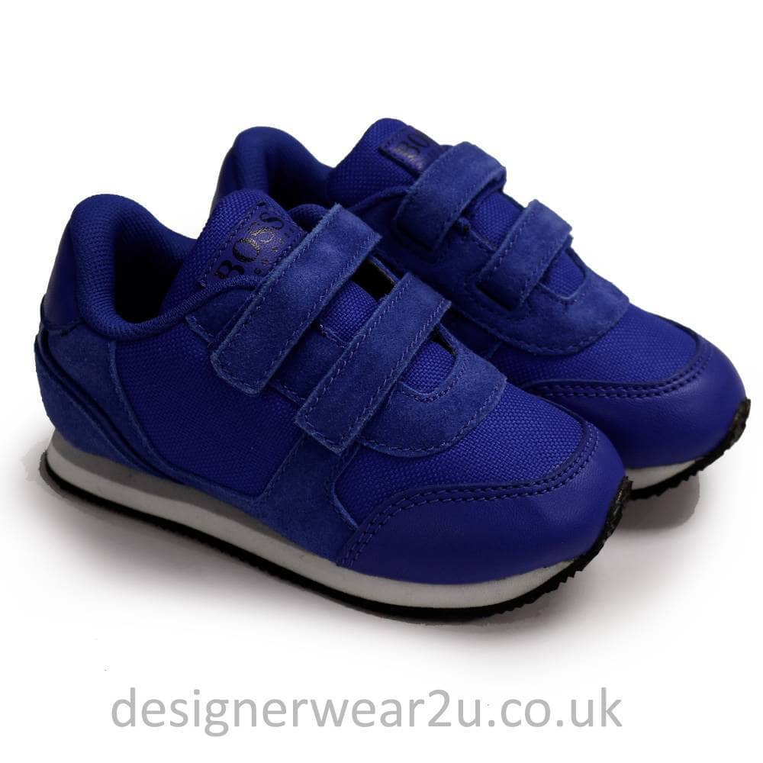





**Home reading books** need to be **returned everyday,** even if your child doesn’t need their book changing, as we like to keep up to date with progress at home and listen to them read in school. Books will be changed **Monday to Thursday** but not on Fridays as it is a short session.

**We hope you all had a lovely Christmas and New Year and it certainly is a new year for Dosbarth Puffins! We are very excited to welcome our Full Time Nursery children, Mrs Thomas and Miss Hughes – we are looking forward to continuing our learning journey together!**

**Home learning activities** will continue to be set every Monday – they will be on our **Puffins tile** on **Hwb j2e** under ‘**Home Learning’**. If you have any questions about accessing Hwb, please get in touch. [mathiask@hwbcymru.net](mailto:mathiask@hwbcymru.net)

 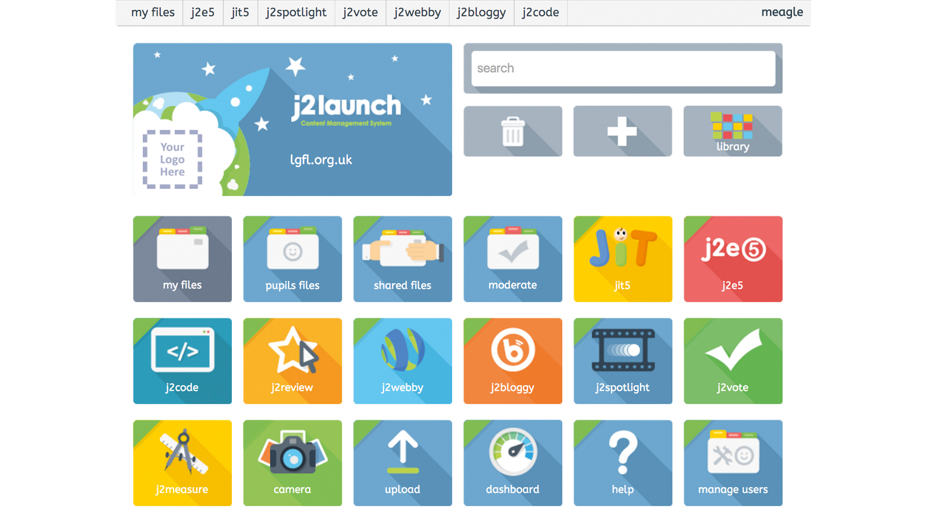

**Welcome back to a new year!**

**January 2022**

**Dosbarth Puffins**

**Snack time**

**Free** milk and fruit/ crackers are available for the children or they can bring a **piece of fruit, crackers or a plain biscuit (no chocolate)** for their daily snack in a named pot or bag. They should also bring in a **named water bottle.**

